Abstract

[Draw your reader in with an engaging abstract. It is typically a short summary of the document.   
When you’re ready to add your content, just click here and start typing.]



john in wells

[Email address]

[Document subtitle]

# Assessment –

# Research & Questioning

|  |  |  |  |
| --- | --- | --- | --- |
| Name of Student | Oleksii Ketskalo | ID | 18849 |

Contents

Assessment – 1

Research & Questioning 1

***Instructions:*** 1

***Business Scenario*** 1

***Task 1: Determine support areas*** 2

***Task 2: Identify stakeholders*** 3

***Task 3: Develop support procedures*** 4

***Task 4: Assign Support Personnel*** 6

***Task 5: Short Answer Questions*** 6

***Task 6: Multiple Choice Questions*** 7

Index 12

#### View My Web Support:

<https://wellsjohn220.github.io/ecbr/>

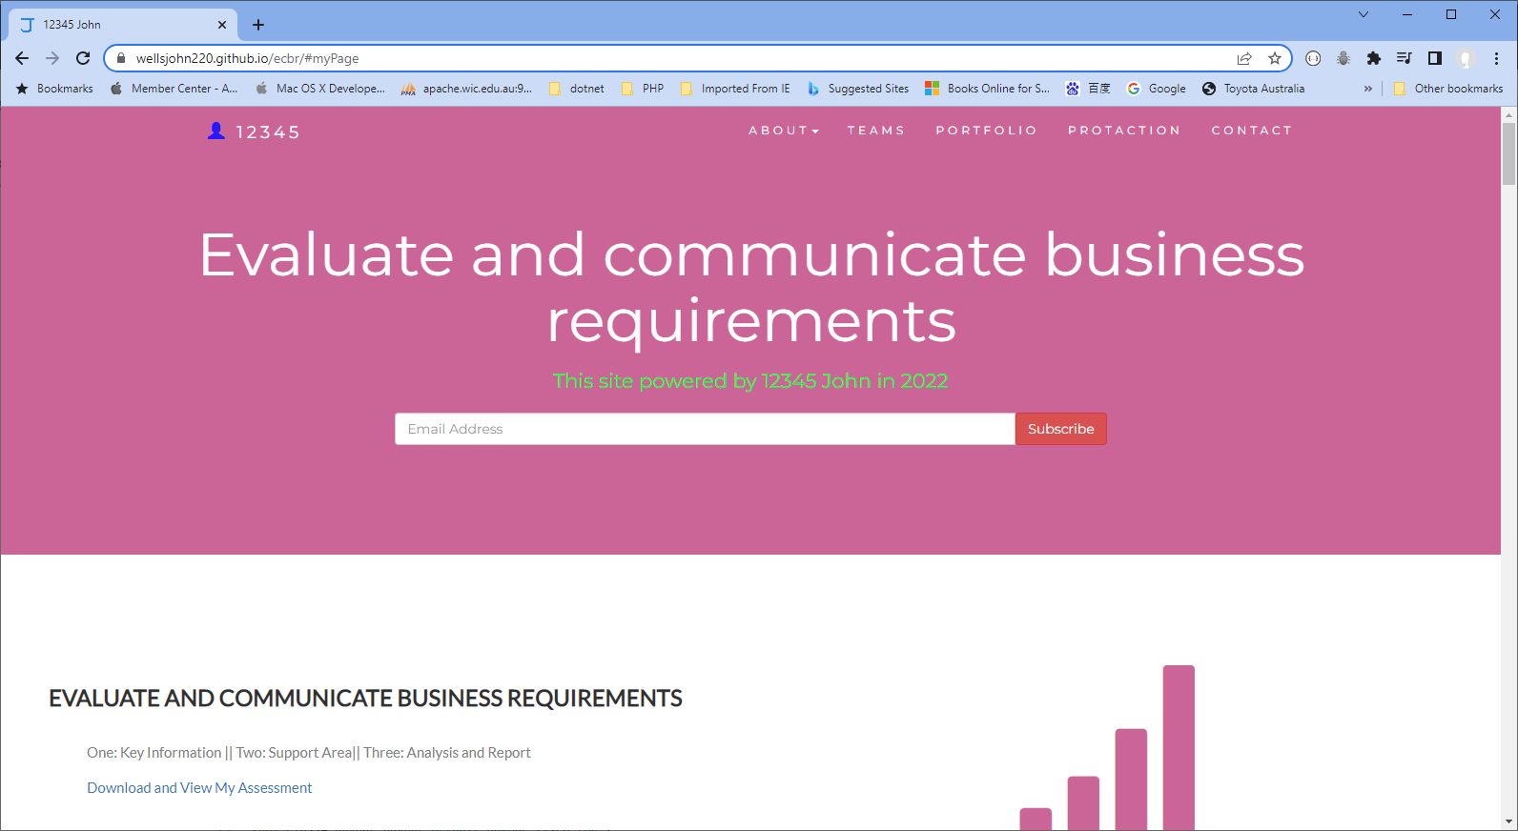

#### or

<https://wellsjohn220.wixsite.com/evaluate>

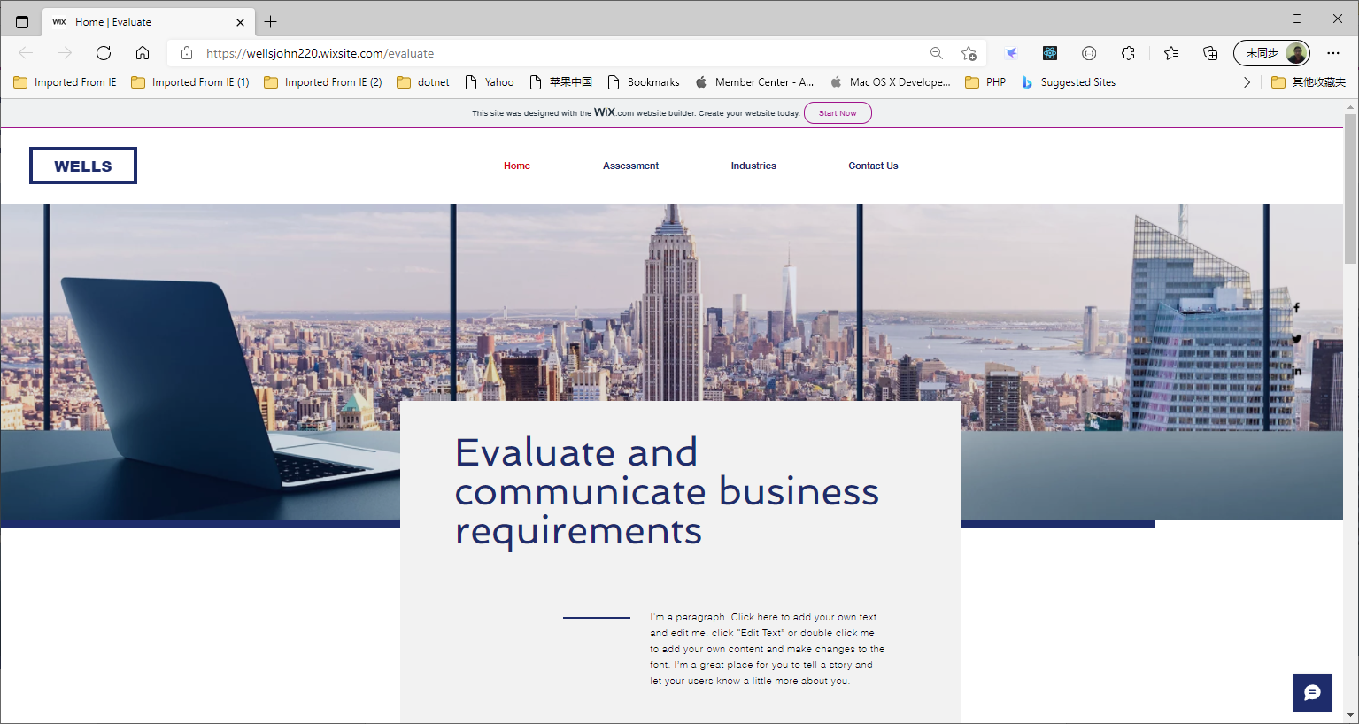

#### *Instructions:*

This assessment is to be completed individually. In this assessment you will be working through a number of written tasks based on case scenarios or research that relate directly to each element of competency for this cluster. Outlined below is information on how each of the tasks relates the element of competency covered.

Learn how to make Google Form: <https://www.youtube.com/watch?v=BtoOHhA3aPQ&t=4s>

Your tasks:

#### *Business Scenario*

D&K Books Pty Ltd is a bookstore owned by Mr. Dean Kerr. The business occupies two levels of an office building connected by escalators and lifts. D&K Books employs approximately six sales staff, one operation manager, two administrative officers, a bookkeeper and a marketing manager. They have an Ethernet network consisting of ten PCs (Intel I3 Desktop cloned), two switches, a router and three printers. They use the QuickBooks software to manage their entire business, including sales, inventory, ordering, accounts receivable, accounts payable, payroll and employee management. They also have two EFTPOS terminals one on each floor.

D&K Books has a Linux server that stores all of the data including the QuickBooks database. The server is backed up to tape regularly. They also have a website (hosted on an Australian ISP’s server, dynamic and static pages using asp.net) on which customers can browse the product catalogue and view current specials. They also lease a telephone system from Live Telecoms. The PABX (phone system) consists of a main switchboard and five remote phones with three incoming lines and a message-on-hold queue system.

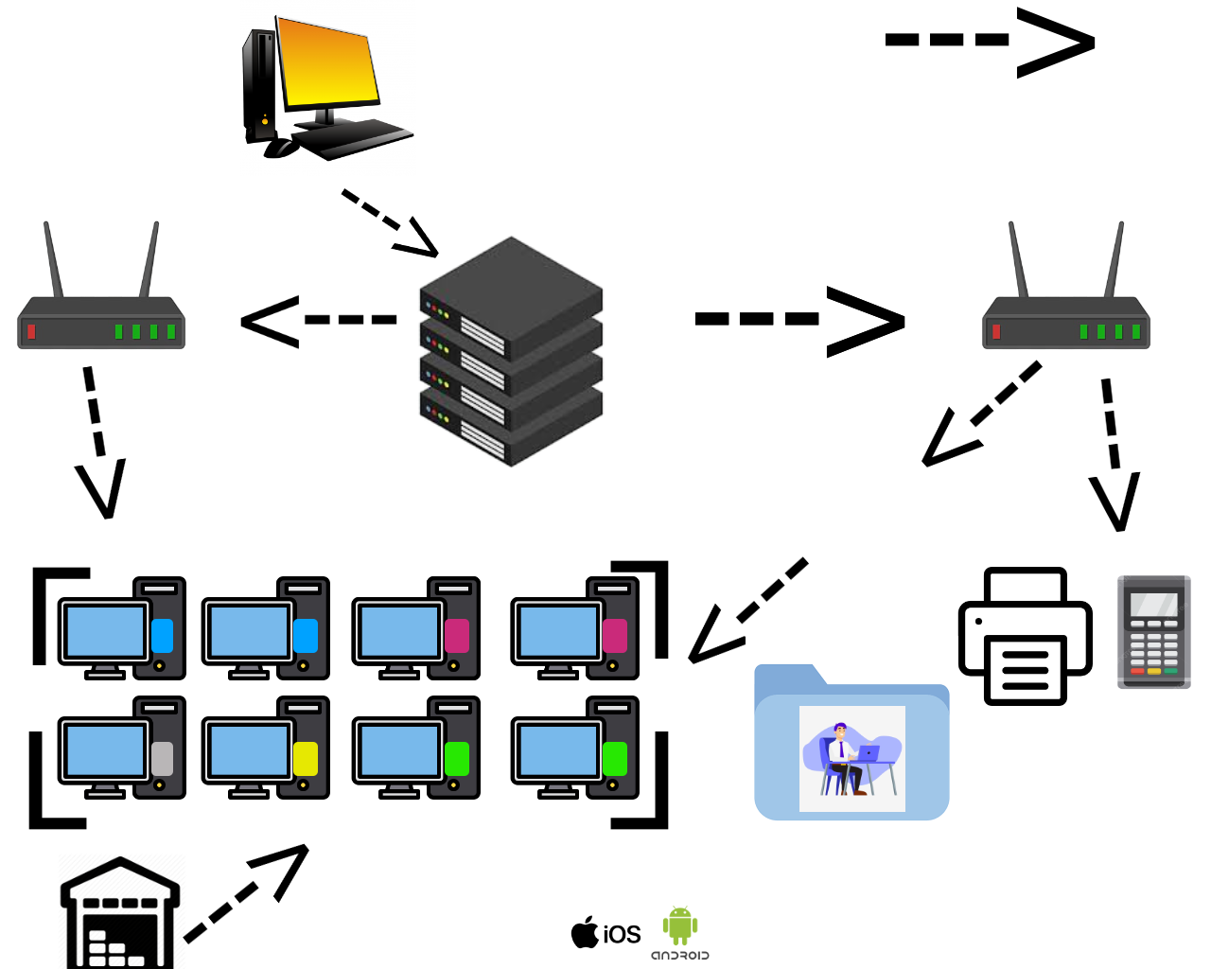



Good network system, you need setup at least:

|  |  |
| --- | --- |
| Hard ware | Software |
| Server X 1 | Window Server |
| Computer X 8 | Windows |
| Printer X 1 | SQL server |
| Telephone X 8 | Virus Protection |
| Modern X 2 | MS office |
| Network Cable | Eftpos machine More… |

#### *http://imapwebsolutions.com/wp-content/uploads/2014/07/linux-dedicated-server.pngTask 1: Determine support areas*

Identify information technology (HW and SW) and list the technology in use in D&K Books and consider the following:

* What sort of support does the technology require?
* Who is likely to provide this support?
* Does the support arrangement already exist?

Present your answer in a table such as the one below:

|  |  |  |  |  |
| --- | --- | --- | --- | --- |
| **Technology** | **Description** | **Support Required** | **Provider** | **Support Already exists? (Yes/No)** |
| QuickBooks Software | software that keeps track of all accounts, stock, GST, etc. | customisation, training, upgrades, bug fixes (patching), user support | [www.intuit.com.au](http://www.intuit.com.au)  online to find more | No |
| PC’s | Intel I3 Desktop cloned | upgrades, repairs, troubleshooting, maintenance, backup, customisation, network to link | thepcdoctor | No. Need find one person to do this job |
| **Server**  IconExperience » V-Collection » Server Icon | Linux Server with tape backup  May need upgrade to hard disk backup | User account management, security policy implementation, home folder management, permissions management, backup and restore, operating system patching, software installation | Quickbooks | No |
| EFTPOS | Easy to use | No need | shop | Yes |
| Telephone system | Low cost | Phone company | Telstra | Yes |
| Website | Low cost | Yes | Godaddy | Yes |
| Network | wireless | No external | No | No |

Please review my website: <https://wellsjohn220.github.io/ecbr/#businesscase>

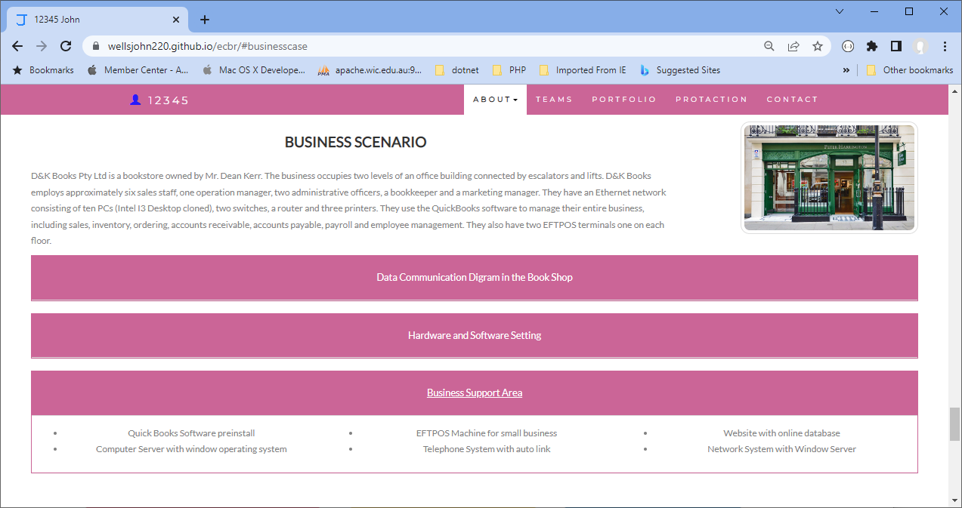

My web contact: [https://wellsjohn220.github.io/ecbr/#contact](https://wellsjohn220.github.io/ecbr/%23contact)

After your input, it will be recorded at:

You could be accessed by:

<https://docs.google.com/spreadsheets/d/1wTeUBT0PdTxWGvYY3XUuvNKIIdWsLb9yQnJgQvYamA8/edit?usp=sharing>

#### *Task 2: Identify stakeholders*

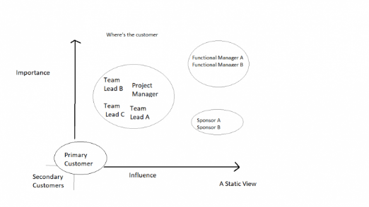Identify stakeholders related in D&K Books system

All the staffs (the business owner, the relevant manager, the local workers and the remote workers) are stakeholders

Your comment: Business owner, Oper. Manager, Market. Manager, 6 sale staff , two admin. Officers, Bookkeeper, Internal/External IT.

#### *Task 3: Develop support procedures*

1. Describe one positive and one negative experience you have had when seeking assistance from a telecommunication company, an ISP or a computer supplier. Your experience may be via telephone, email or even voice recognition.

|  |  |  |
| --- | --- | --- |
| Type | Positive | Negative |
| Telephone | Easy to get answer | Document provide |
| Email | Document, Picture, words or any media | Have to wait |
| Go to company | Face to face get answer | Cost time and money on trip |
| Website | Easy to access | Need to find FAQ section + May not receive good enough answer |

1. Using the experiences described above please answer the following questions.
   1. What support aspects were professional and/or unprofessional?
   2. How long did the support process take?
   3. Were the steps logical?
   4. Did they solve your problem?
   5. Was the call deflected to another area?

|  |  |  |
| --- | --- | --- |
| Items | professional | unprofessional |
| What support aspects | Friendly, Listening | Not what know your customer |
| How long | Very quick | Waiting and waiting |
| Steps logical | Yes | No |
| Solve | Good | Can not |
| Another area | If has, need solve | If has, do not care |

Using feedback form or Google survey form.

Here is the very simple survey demo:

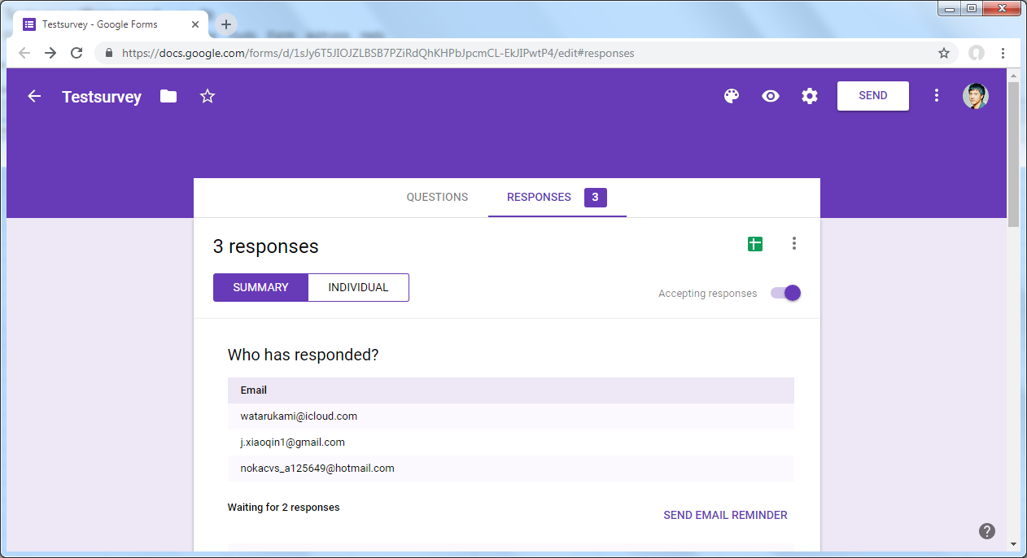

After I tested my friends, I could get nice response like:

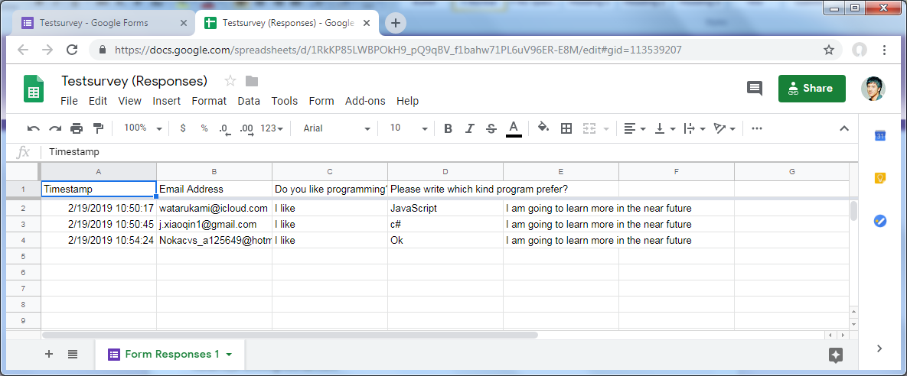

Or using link string:

<https://docs.google.com/spreadsheets/d/1RkKP85LWBPOkH9_pQ9qBV_f1bahw71PL6uV96ER-E8M/edit#gid=113539207>

Please review my website: [https://wellsjohn220.github.io/ecbr/#taskthree](https://wellsjohn220.github.io/ecbr/%23taskthree)

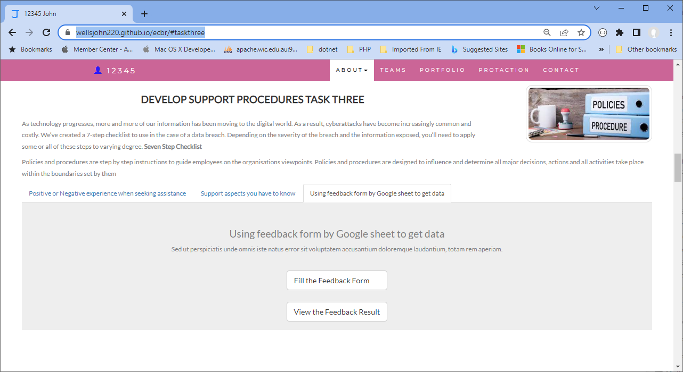  
  
Here’s my connected to google sheets survey: <https://docs.google.com/spreadsheets/d/1UNGn4KbnU67ntCoZQIP_9Mm3L6pTnYOfwMtwIGvUkTo/edit?resourcekey#gid=388910615>  
Also link to it: https://docs.google.com/spreadsheets/d/1UNGn4KbnU67ntCoZQIP_9Mm3L6pTnYOfwMtwIGvUkTo/edit?usp=sharing

#### *Task 4: Assign Support Personnel*

Classify the following into soft skills and technical skills. Your answer should take the form of a table shown below.

|  |  |  |
| --- | --- | --- |
| **Skill** | **Soft skill** | **Technical skill** |
| A knowledge of Linux | X |  |
| The ability to work under pressure | X |  |
| The administration of Windows 2008 Server |  | X |
| The ability to formulate network and IT policies |  | X |
| The ability to write network documentation | X |  |
| The ability to give presentations | X |  |

#### *Task 5: Short Answer Questions*

1. 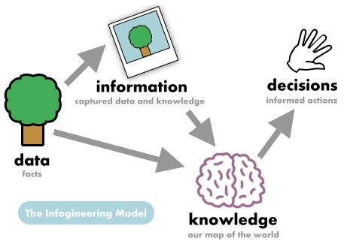Explain the relationship between data, information and knowledge.

Data: Raw, unprocessed facts.   
Info: Processed, organised facts. Useful for making decisions unlike data.   
Knowledge: Already used in practice information based on experience or otherwise. Better than both, Data and Info

1. What is quantitative data and how can you use it.

Quantitative data is numerical and measurable data used to represent quantities or amounts.  
Where to use it: Business, healthcare, education, marketing

1. What is qualitative data and how can you use it.

Qualitative data is non-numerical data that captures qualities, characteristics, and descriptions. It is used to understand concepts, opinions, or experiences.  
Used in: Thematic analysis, content analysis, case studies, etc.

1. 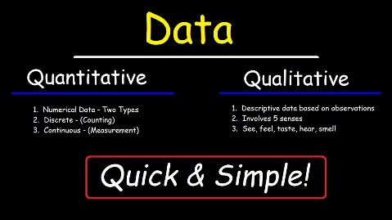Give an example of how quantitative and qualitative data can be used in conjunction with each other

Analyzing customer feedback alongside sales figures can reveal trends. For instance, noticing a surge in positive comments about a new product alongside a spike in sales indicates its popularity.

1. What sort of methods could you use to determine client requirements for a website design and key information sources?

Analyzing customer feedback (qualitative) alongside sales figures (quantitative) can reveal trends. For instance, noticing a surge in positive comments about a new product alongside a spike in sales indicates its popularity.

1. Give some examples of client requirements for a website design

* Looks good
* 24 hours work
* Easy to update
* Upgrade is free
* Easy to contact
* Helpful support

#### *Task 6: Multiple Choice Questions*

1. 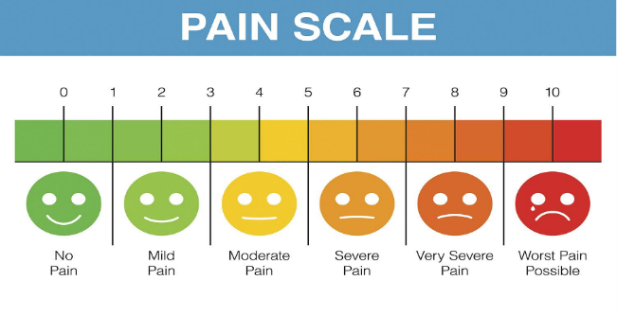Generally, how many points should a rating scale have?
   1. Five
   2. Four
   3. Ten
   4. Somewhere from 4 to 11 points   
      Reason: Because 4 to 11 points will make the scale the most easy-to-use and will give a clear understanding of what it means. Might also be around 100 points as might have even more info in.

Web refer: <https://lumoa.me/blog/rating-scale>

A rating scale is a closed-end survey question that is used to evaluate how survey responders feel about a particular product or statement.

Comment: I like 10 points. It is easy and clear to get the best feedback way.  
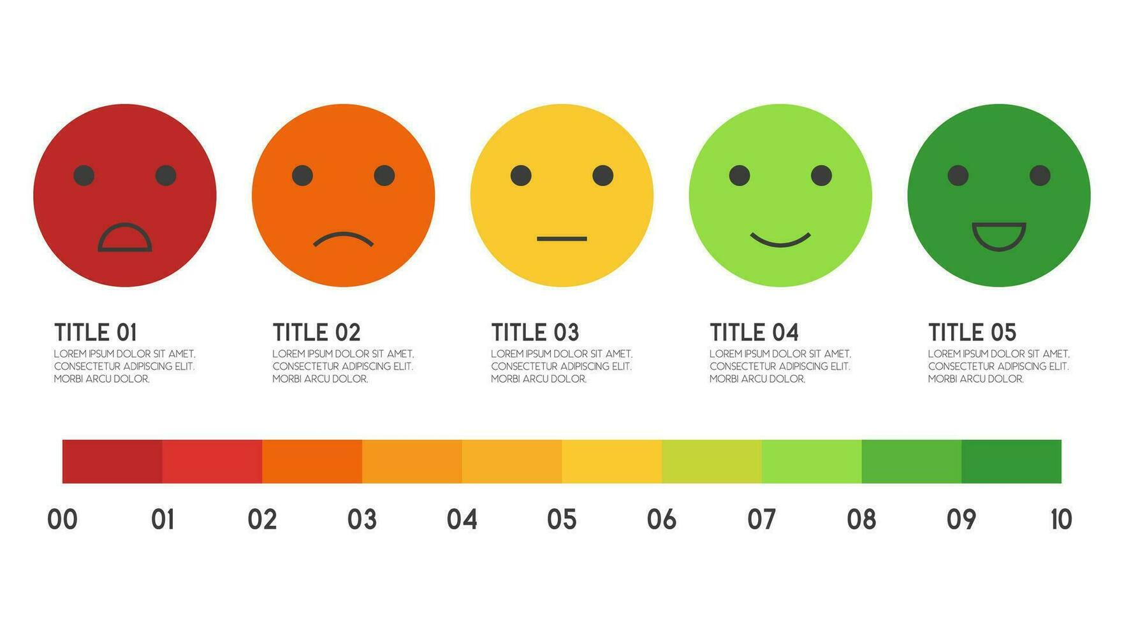

1. What is the problem(s) with this set of response categories to the question “What is your current age?”

* 1-5
* 5-10
* 10-20
* 20-30
* 30-40
  1. The categories are not mutually exclusive
  2. The categories are not exhaustive
  3. Both a and b are problems   
     Reason: The categories doesn’t make a lot of sense because the age must have its own distribution trough numbers of years. A good example will be: 12-16 16-18 21-30 31-40 etc.  
     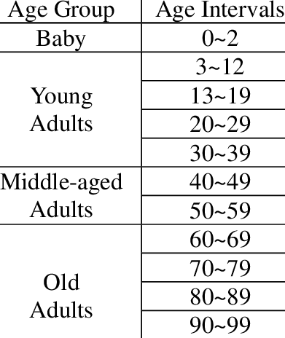

Good example and also link to it https://www.google.com/url?sa=i&url=https%3A%2F%2Fwww.researchgate.net%2Ffigure%2FAge-intervals-and-age-groups_tbl1_228404297&psig=AOvVaw2mhHxaOowBRaGDRdjiIGMv&ust=1716864145088000&source=images&cd=vfe&opi=89978449&ved=0CBQQjhxqFwoTCKDLiL_nrIYDFQAAAAAdAAAAABAE

1. You should mix methods in a way that provides complementary strengths and no overlapping weaknesses. This is known as the fundamental principle of mixed research.
   1. True   
      Reason: The reason for mixing methods in research is to leverage the complementary strengths of different approaches while minimizing their individual weaknesses  
      link https://www.deakin.edu.au/__data/assets/pdf_file/0020/681023/Dr-r-cameron_mixed-methodology.pdf  
      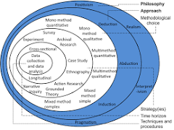
   2. False
2. According to the text, questionnaires can address events and characteristics taking place when?
   1. In the past (retrospective questions)
   2. In the present (current time questions)
   3. In the future (prospective questions)
   4. All of the above   
      Reason:
   5. Questionnaires can address events and characteristics taking place at any point in time, including past, present, or future occurrences.
3. Which of the following are principles of questionnaire construction?
   1. Consider using multiple methods when measuring abstract constructs
   2. Use multiple items to measure abstract constructs
   3. Avoid double-barrelled questions
   4. All of the above
   5. Only b and c   
      Reason

The principles of questionnaire construction include using multiple items to measure abstract constructs and avoiding double-barreled questions.

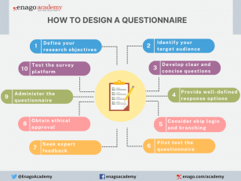  
link: https://www.google.com/url?sa=i&url=https%3A%2F%2Fwww.enago.com%2Facademy%2Fresearch-questionnaires%2F&psig=AOvVaw14NTrlWX4gsXRW_DaQEP2J&ust=1716864743234000&source=images&cd=vfe&opi=89978449&ved=0CBQQjhxqFwoTCODY3NrprIYDFQAAAAAdAAAAABAE

1. Which of these is not a method of data collection?
   1. Questionnaires
   2. Interviews
   3. Experiments Reason
   4. Observations  
      https://www.google.com/url?sa=i&url=https%3A%2F%2Fwww.questionpro.com%2Fblog%2Fdata-collection-methods%2F&psig=AOvVaw1_pdajyH3D9lVqOi6-bViC&ust=1716883270208000&source=images&cd=vfe&opi=89978449&ved=0CBQQjhxqFwoTCLDJjt2urYYDFQAAAAAdAAAAABAE  
      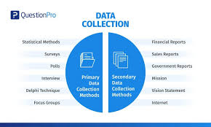

Reason: Experiments are a method of data analysis, not data collection.

1. Secondary/existing data may include which of the following?
   1. Official documents
   2. Personal documents
   3. Archived research data
   4. All of the above Reason

Reason: Secondary or existing data can come from various sources, including official documents, personal documents, and archived research data.  
link: https://www.google.com/url?sa=i&url=https%3A%2F%2Fblog.marketresearch.com%2Fnot-all-market-research-data-is-equal&psig=AOvVaw0ZzjG6RekLw5QQhxZevYyn&ust=1716883376271000&source=images&cd=vfe&opi=89978449&ved=0CBQQjhxqFwoTCIC20ZCvrYYDFQAAAAAdAAAAABAE  
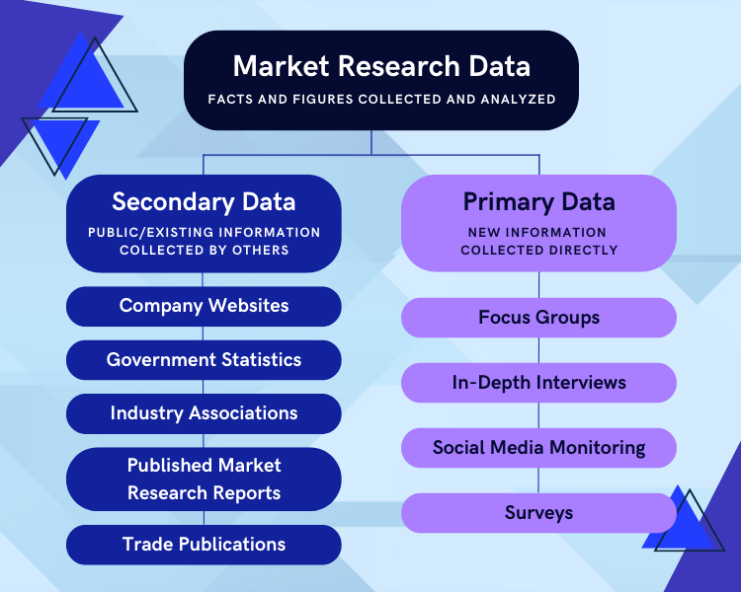

1. An item that directs participants to different follow-up questions depending on their response is called a ____________.
   1. Response set
   2. Probe
   3. Semantic differential
   4. Contingency question Reason  
      Reason: A contingency question directs participants to different follow-up questions based on their response to the initial question.  
      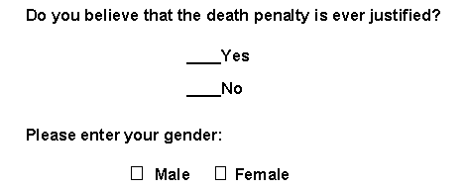  
      https://www.google.com/url?sa=i&url=https%3A%2F%2Fconjointly.com%2Fkb%2Ftypes-of-survey-questions%2F&psig=AOvVaw3tPkyqkBvy2Oht1u4SEZbU&ust=1716883460761000&source=images&cd=vfe&opi=89978449&ved=0CBQQjhxqFwoTCND_jbyvrYYDFQAAAAAdAAAAABAZ
2. Which of the following te  
   rms best describes data that were originally collected at an earlier time by a different person for a different purpose?
   1. Primary data
   2. Secondary data Reason
   3. Experimental data
   4. Field notes

Reason: Secondary data refers to data that were originally collected by someone else for a different purpose at an earlier time.

https://www.google.com/url?sa=i&url=https%3A%2F%2Fwww.questionpro.com%2Fblog%2Fdata-collection-methods%2F&psig=AOvVaw1_pdajyH3D9lVqOi6-bViC&ust=1716883270208000&source=images&cd=vfe&opi=89978449&ved=0CBQQjhxqFwoTCLDJjt2urYYDFQAAAAAdAAAAABAE  


1. Researchers use both open-ended and closed-ended questions to collect data. Which of the following statements is true?
   1. Open-ended questions directly provide quantitative data based on the researcher’s predetermined response categories
   2. Closed-ended questions provide quantitative data in the participant’s own words
   3. Open-ended questions provide qualitative data in the participant’s own words Reason
   4. Closed-ended questions directly provide qualitative data in the participants’ own words

Reason: Open-ended questions allow participants to respond in their own words, generating qualitative data.  
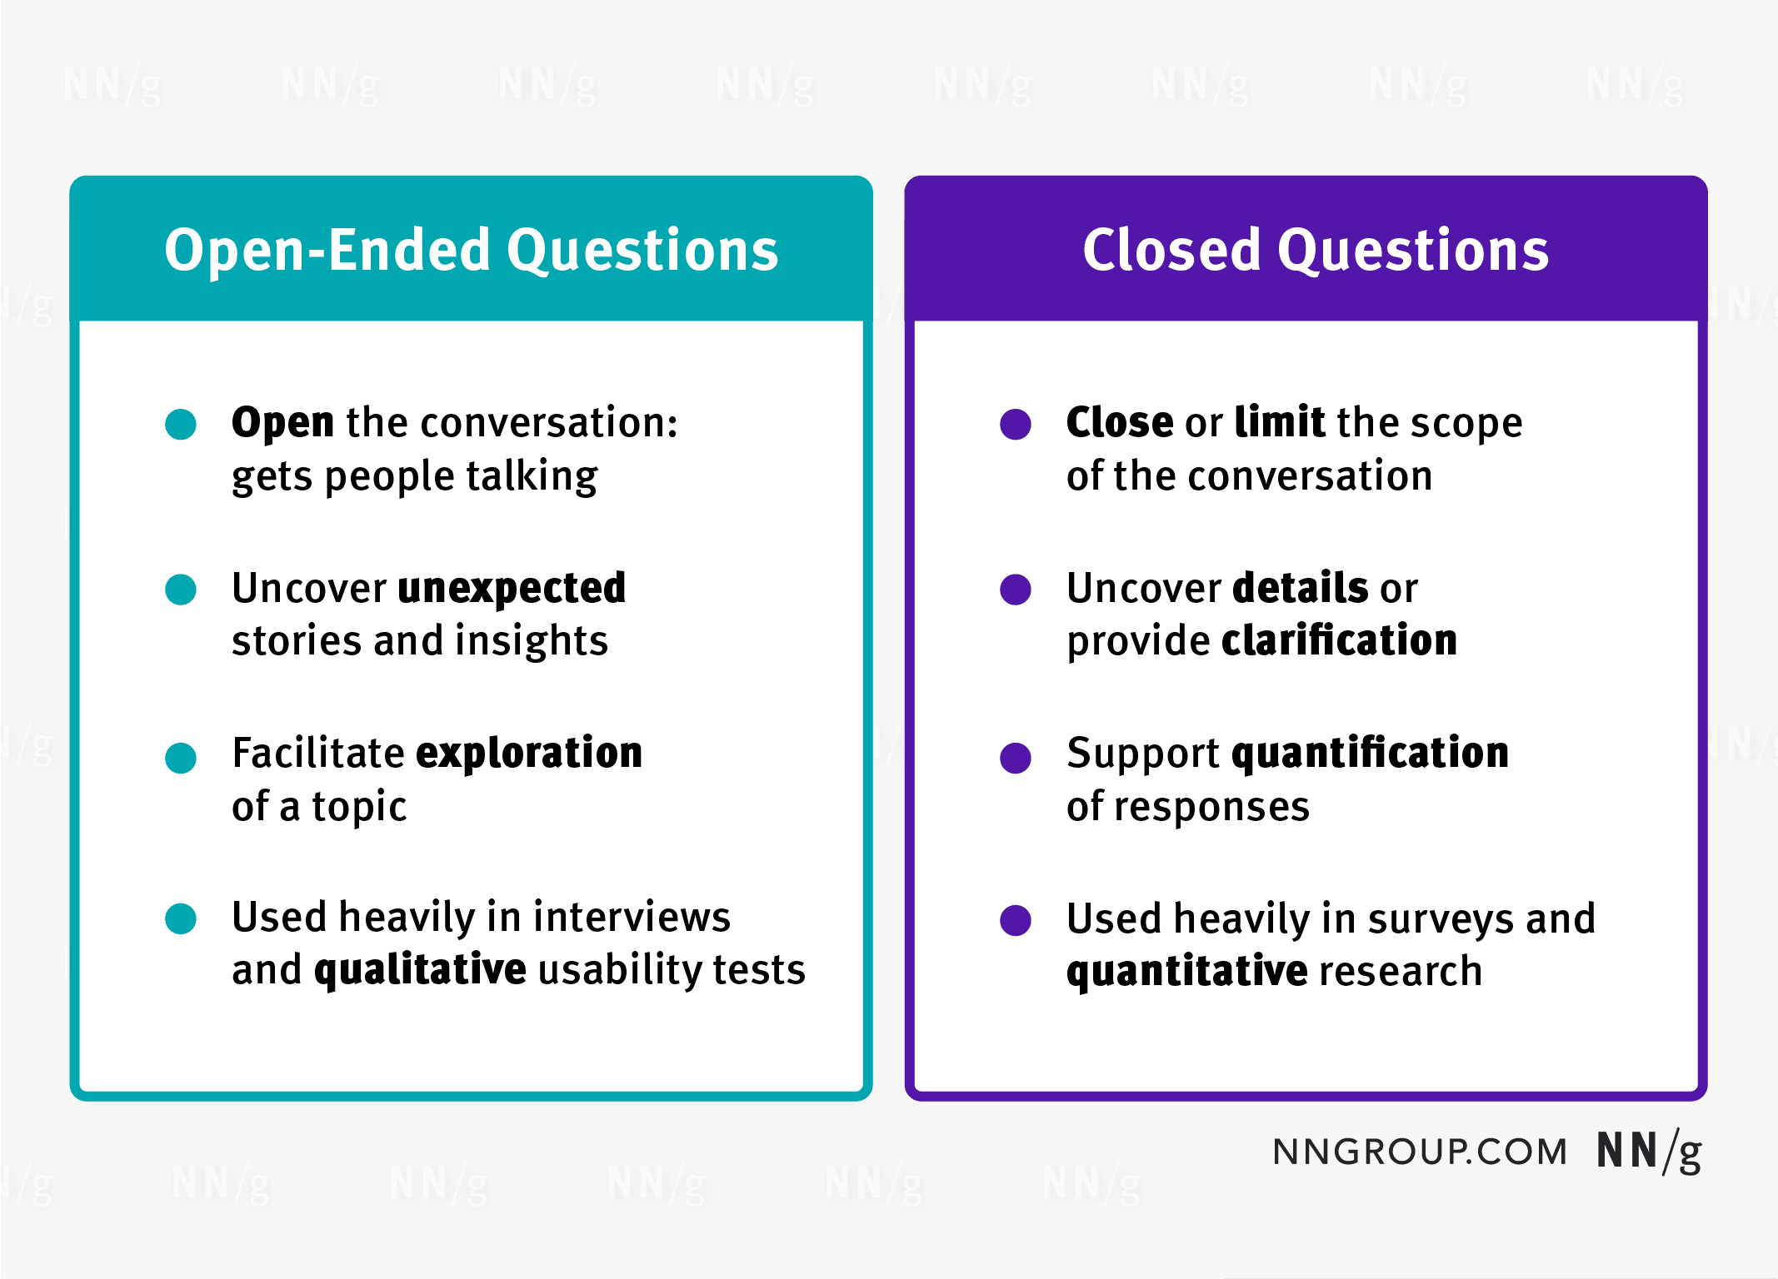  
https://www.google.com/url?sa=i&url=https%3A%2F%2Fwww.nngroup.com%2Farticles%2Fopen-ended-questions%2F&psig=AOvVaw1kr4f31d8TJ9GjnxcnDquW&ust=1716883736963000&source=images&cd=vfe&opi=89978449&ved=0CBQQjhxqFwoTCLDWn8KwrYYDFQAAAAAdAAAAABAE

1. Open-ended questions provide primarily ______ data.
   1. Confirmatory data
   2. Qualitative data Reason
   3. Predictive data
   4. None of the above  
      Reason: Open-ended questions allow participants to respond in their own words, which generates qualitative data.

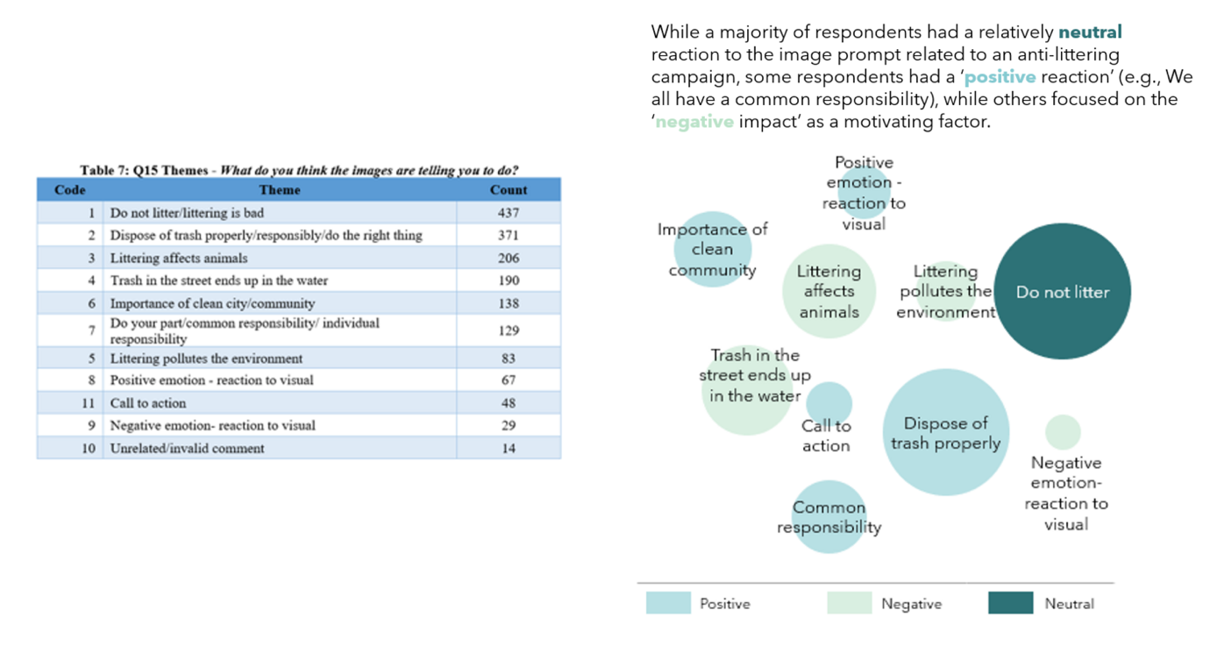

https://www.google.com/url?sa=i&url=https%3A%2F%2Fwww.surveypractice.org%2Farticle%2F25699-what-to-do-with-all-those-open-ended-responses-data-visualization-techniques-for-survey-researchers&psig=AOvVaw3o3cJHZE9LkZWLcF4qakqu&ust=1716883813421000&source=images&cd=vfe&opi=89978449&ved=0CBQQjhxqFwoTCMid_OCwrYYDFQAAAAAdAAAAABAE

1. Which of the following is true concerning observation?
   1. It takes less time than self-report approaches
   2. It costs less money than self-report approaches
   3. It is often not possible to determine exactly why the people behave as they do Reason
   4. All of the above  
      Reason: Observation allows researchers to see what people do, but it doesn't provide insights into their motivations or reasons for their behavior.  
      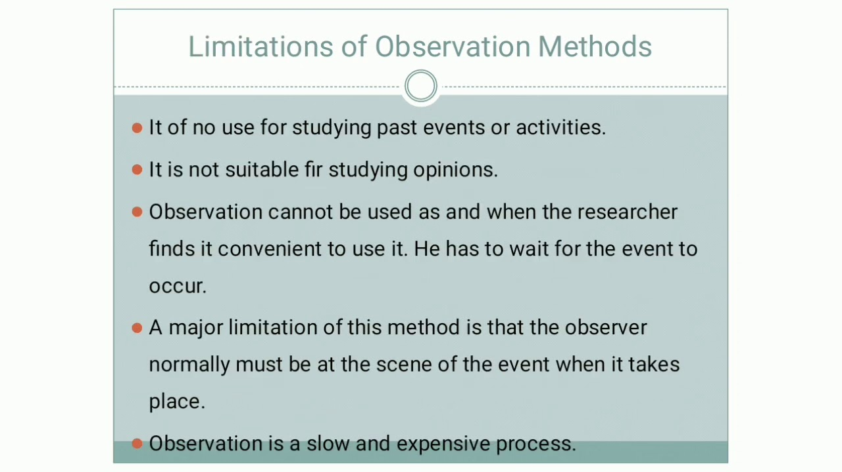  
      https://www.google.com/url?sa=i&url=https%3A%2F%2Fm.youtube.com%2Fwatch%3Fv%3DLIUC_LLeoFU&psig=AOvVaw2SVA_5RKuWYqQXyWzOHoDg&ust=1716883908924000&source=images&cd=vfe&opi=89978449&ved=0CBQQjhxqFwoTCIiHu42xrYYDFQAAAAAdAAAAABAE
2. Qualitative observation is usually done for exploratory purposes; it is also called ___________ observation.
   1. Structured
   2. Naturalistic Reason
   3. Complete
   4. Probed

Reason: Qualitative observation aimed at exploring subjects in their natural environment is called naturalistic observation.  
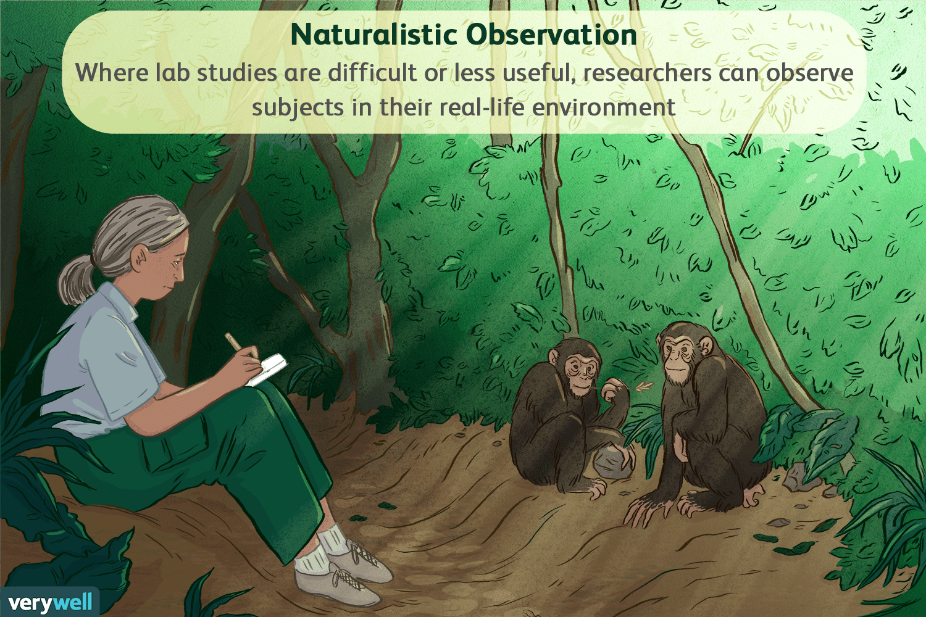  
https://www.google.com/url?sa=i&url=https%3A%2F%2Fwww.verywellmind.com%2Fwhat-is-naturalistic-observation-2795391&psig=AOvVaw2J9OImCkRf_YErPQQ2yFGf&ust=1716883956235000&source=images&cd=vfe&opi=89978449&ved=0CBQQjhxqFwoTCLigkqSxrYYDFQAAAAAdAAAAABAE

1. When constructing a questionnaire, it is important to do each of the following except ______.
   1. Use "leading" or "loaded" questions Reason
   2. Use natural language
   3. Understand your research participants
   4. Pilot your test questionnaire  
      Reason: Leading or loaded questions can bias the responses and are not recommended in questionnaire construction.  
      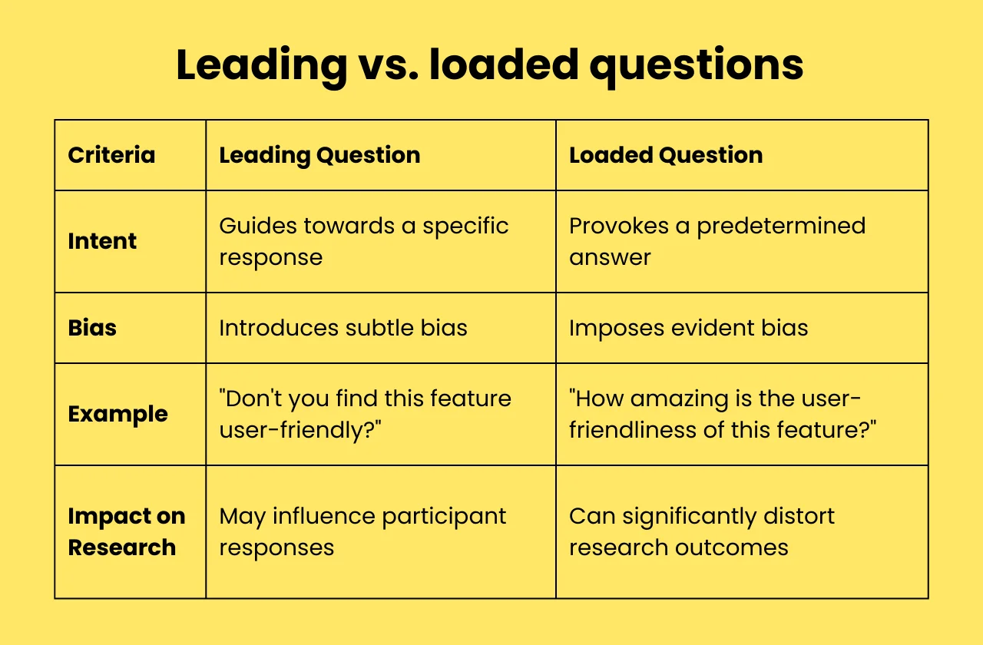  
      https://www.google.com/url?sa=i&url=https%3A%2F%2Fwww.blitzllama.com%2Fblog%2Fleading-questions-examples&psig=AOvVaw1Y2X0RbIy9XLCGjAnnTrqT&ust=1716884060225000&source=images&cd=vfe&opi=89978449&ved=0CBQQjhxqFwoTCIif0taxrYYDFQAAAAAdAAAAABAE
2. Another name for a Likert Scale is a(n):
   1. Interview protocol
   2. Event sampling
   3. Summated rating scale Reason
   4. Ranking  
      Reason: A Likert Scale is also known as a summated rating scale because it sums responses across multiple items to measure a concept.  
      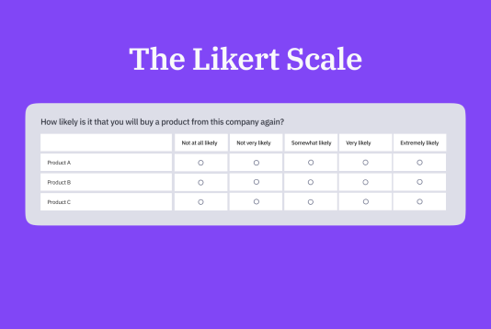  
      https://www.google.com/url?sa=i&url=https%3A%2F%2Fwww.limesurvey.org%2Fblog%2Fknowledge%2F108-the-likert-scale-enhance-your-survey-data&psig=AOvVaw0sCjt3M3rpkjfJlp0E19vB&ust=1716884114794000&source=images&cd=vfe&opi=89978449&ved=0CBQQjhxqFwoTCPi24u-xrYYDFQAAAAAdAAAAABAI
3. Which of the following is not one of the six major methods of data collection that are used by educational researchers?
   1. Observation
   2. Interviews
   3. Questionnaires
   4. Checklists Reason

Reason: While observation, interviews, and questionnaires are common methods used by educational researchers, checklists are not typically considered one of the major methods of data collection in educational research.  
  
https://www.google.com/url?sa=i&url=https%3A%2F%2Fwww.questionpro.com%2Fblog%2Fdata-collection-methods%2F&psig=AOvVaw22gxbqCjFMqHkel25RHQUt&ust=1716884204764000&source=images&cd=vfe&opi=89978449&ved=0CBQQjhxqFwoTCJD6xZqyrYYDFQAAAAAdAAAAABAE

1. The type of interview in which the specific topics are decided in advance but the sequence and wording can be modified during the interview is called:
   1. The interview guide approach Reason
   2. The informal conversational interview
   3. A closed quantitative interview
   4. The standardized open-ended interview  
      Reason: In the interview guide approach, specific topics are predetermined, but the interviewer has flexibility in the sequence and wording of questions during the interview.  
      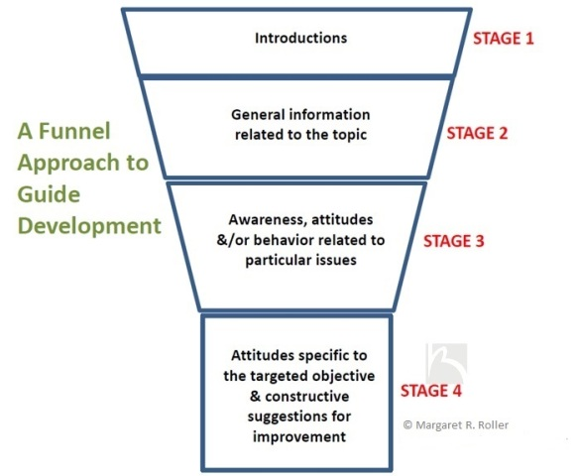  
      https://www.google.com/url?sa=i&url=https%3A%2F%2Fresearchdesignreview.com%2F2015%2F06%2F28%2Finterview-guide-development-a-4-stage-funnel-approach%2F&psig=AOvVaw1iBgp-Qf7jUQXgILk4ERiY&ust=1716884255884000&source=images&cd=vfe&opi=89978449&ved=0CBQQjhxqFwoTCNj68rKyrYYDFQAAAAAdAAAAABAE
2. Which one of the following in not a major method of data collection:
   1. Questionnaires
   2. Interviews Reason
   3. Secondary data
   4. Focus groups
   5. All of the above are methods of data collection  
      Questionnaires, interviews, secondary data, and focus groups are all major methods of data collection commonly used in research.  
      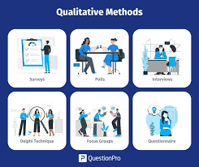  
      https://www.google.com/url?sa=i&url=https%3A%2F%2Fwww.questionpro.com%2Fblog%2Fdata-collection-methods%2F&psig=AOvVaw1sTAvpU4Yiqb4yJ99U-Ace&ust=1716884306433000&source=images&cd=vfe&opi=89978449&ved=0CBQQjhxqFwoTCNiE8s2yrYYDFQAAAAAdAAAAABAE
3. A question during an interview such as “Why do you feel that way?” is known as a:
   1. Probe Reason
   2. Filter question
   3. Response
   4. Pilot  
      Reason: A probe is a question or statement used by an interviewer to elicit more information or clarification from the respondent.  
      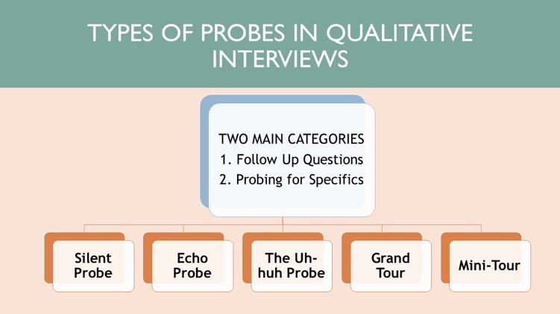

https://www.google.com/url?sa=i&url=https%3A%2F%2Fwww.linkedin.com%2Fpulse%2Fmain-types-probes-qualitative-interviews-&psig=AOvVaw0tAAlOOqpBMw7Nzw8tPk_m&ust=1716884354628000&source=images&cd=vfe&opi=89978449&ved=0CBQQjhxqFwoTCPCPg-KyrYYDFQAAAAAdAAAAABAE

1. A census taker often collects data through which of the following?
   1. Standardized tests
   2. Interviews
   3. Secondary data
   4. Observations Reason  
      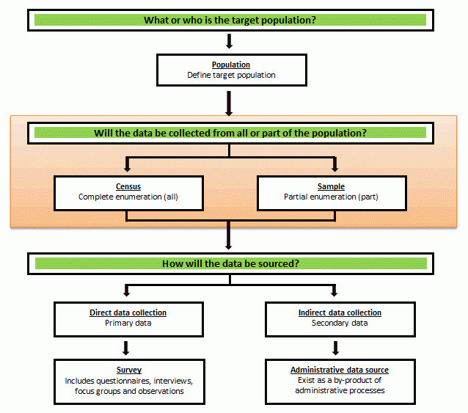

https://www.google.com/url?sa=i&url=https%3A%2F%2Fwww.abs.gov.au%2Fstatistics%2Funderstanding-statistics%2Fstatistical-terms-and-concepts%2Fcensus-and-sample&psig=AOvVaw3sh8C_MgJe9CjJgyzlLN-b&ust=1716884418857000&source=images&cd=vfe&opi=89978449&ved=0CBQQjhxqFwoTCNiW0ICzrYYDFQAAAAAdAAAAABAE

1. The researcher has secretly placed him or herself (as a member) in the group that is being studied. This researcher may be which of the following?
   1. A complete participant Reason
   2. An observer-as-participant
   3. A participant-as-observer
   4. None of the above  
      Reason: A complete participant is fully immersed in the group being studied, often without the group's awareness of the researcher's role.  
      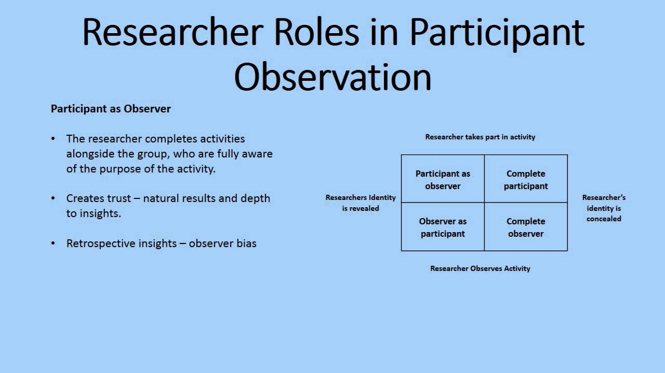  
      https://www.google.com/url?sa=i&url=https%3A%2F%2Fwww.youtube.com%2Fwatch%3Fv%3DZAkrP9bFXzA&psig=AOvVaw20cvdt1pTp-cw4PVbV8HwF&ust=1716884472122000&source=images&cd=vfe&opi=89978449&ved=0CBQQjhxqFwoTCODDgJqzrYYDFQAAAAAdAAAAABAE
2. Which of the following is not a major method of data collection?
   1. Questionnaires
   2. Focus groups
   3. Correlational method Reason
   4. Secondary data  
      Reason: The correlational method is a statistical technique used to determine the relationship between variables and is not a method of data collection.  
      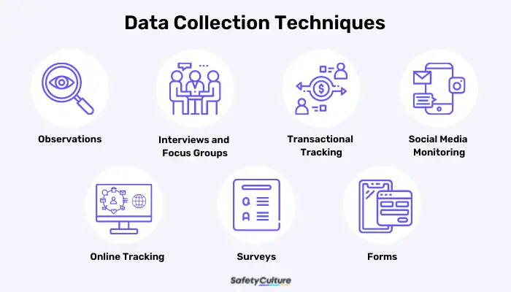  
      https://www.google.com/url?sa=i&url=https%3A%2F%2Fsafetyculture.com%2Ftopics%2Fdata-collection%2Fdata-collection-techniques%2F&psig=AOvVaw1os3LcNvZjSkLhFQUO6QKw&ust=1716884583206000&source=images&cd=vfe&opi=89978449&ved=0CBQQjhxqFwoTCMjnqM-zrYYDFQAAAAAdAAAAABAI
3. Which type of interview allows the questions to emerge from the immediate context or course of things?
   1. Interview guide approach
   2. Informal conversational interview Reason
   3. Closed quantitative interview
   4. Standardized open-ended interview

Reason: In an informal conversational interview, questions emerge naturally from the flow of conversation and immediate context, rather than following a predetermined guide.  
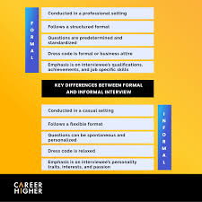  
https://www.google.com/url?sa=i&url=https%3A%2F%2Fwww.careerhigher.co%2Fcareer-advice%2Fhow-to-prepare-for-an-informal-interview-and-succeed-a-guide-with-examples-133916%2F&psig=AOvVaw1tPM8YlkDBsEQMemxw8PrN&ust=1716884661236000&source=images&cd=vfe&opi=89978449&ved=0CBQQjhxqFwoTCJiyx_azrYYDFQAAAAAdAAAAABAE

1. When conducting an interview, asking "Anything else?, What do you mean?, Why do you feel that way?," etc, are all forms of:
   1. Contingency questions
   2. Probes Reason
   3. Protocols
   4. Response categories

Reason: Probes are questions or statements used by interviewers to encourage respondents to provide more information or clarification about their responses.  
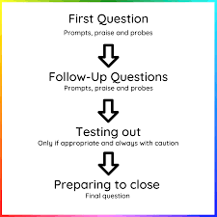  
https://www.google.com/url?sa=i&url=https%3A%2F%2Fneuroqual.org%2Funits%2Funit3%2F&psig=AOvVaw29A60NYB55SAgJoo1tLDGC&ust=1716884712533000&source=images&cd=vfe&opi=89978449&ved=0CBQQjhxqFwoTCMCay420rYYDFQAAAAAdAAAAABAE

1. When constructing a questionnaire, there are 15 principles to which you should adhere. Which of the following is not one of those principles?
   1. Do not use "leading" or "loaded" questions
   2. Avoid double-barrelled questions
   3. Avoid double negatives
   4. Avoid using multiple items to measure a single construct Reason  
      Reason: Using multiple items to measure a single construct is a common practice in questionnaire construction to enhance reliability and validity.  
        
      https://www.google.com/url?sa=i&url=https%3A%2F%2Fwww.enago.com%2Facademy%2Fresearch-questionnaires%2F&psig=AOvVaw2DlZFfqWcl3tMe_igR9zFc&ust=1716884774840000&source=images&cd=vfe&opi=89978449&ved=0CBQQjhxqFwoTCIj686q0rYYDFQAAAAAdAAAAABAE
2. A customer-based Service Level Agreement structure includes:
   1. An SLA covering all Customer groups and all the services they use
   2. SLAs for each service that are Customer-focused and written in business language
   3. An SLA for each service type, covering all those Customer groups that use that Service
   4. An SLA with each individual Customer group, covering all of the services they use Reason  
      Reason: In a customer-based Service Level Agreement (SLA) structure, SLAs for each service are tailored to the specific needs and expectations of customers, written in a language that is easily understandable by the business stakeholders.  
      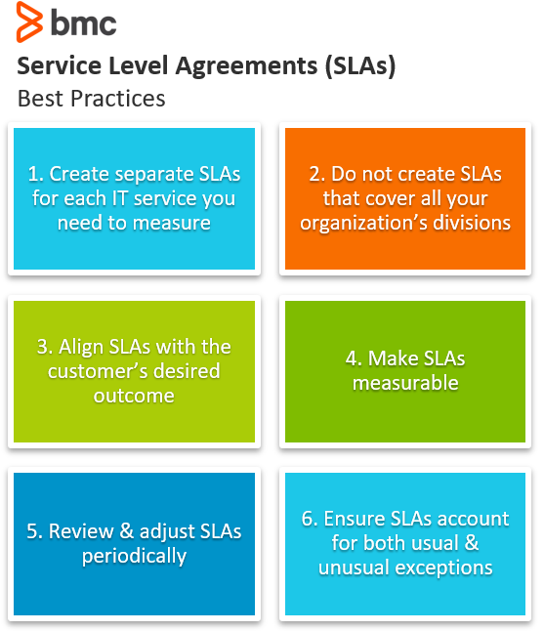  
      https://www.google.com/url?sa=i&url=https%3A%2F%2Fwww.bmc.com%2Fblogs%2Fsla-best-practices%2F&psig=AOvVaw23rgK4op5z9j9ghr1CgHat&ust=1716884825392000&source=images&cd=vfe&opi=89978449&ved=0CBQQjhxqFwoTCPDCwMK0rYYDFQAAAAAdAAAAABAE
3. Which of the following best describes the goal of Service Level Management?
   1. To maintain and improve IT service quality in line with business requirements Reason
   2. 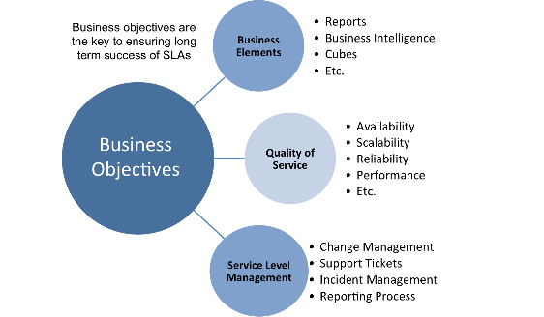To provide IT services at the lowest possible cost by agreeing with Customers their minimum requirements for service availability and ensuring performance does not exceed these targets
   3. To provide the highest possible level of service to Customers and continuously improve on this through ensuring all services operate at maximum availability
   4. To ensure that IT delivers the same standard of service at the least cost

Reason: Service Level Management aims to align IT services with the needs and expectations of the business, ensuring that the quality of IT services meets or exceeds business requirements.  
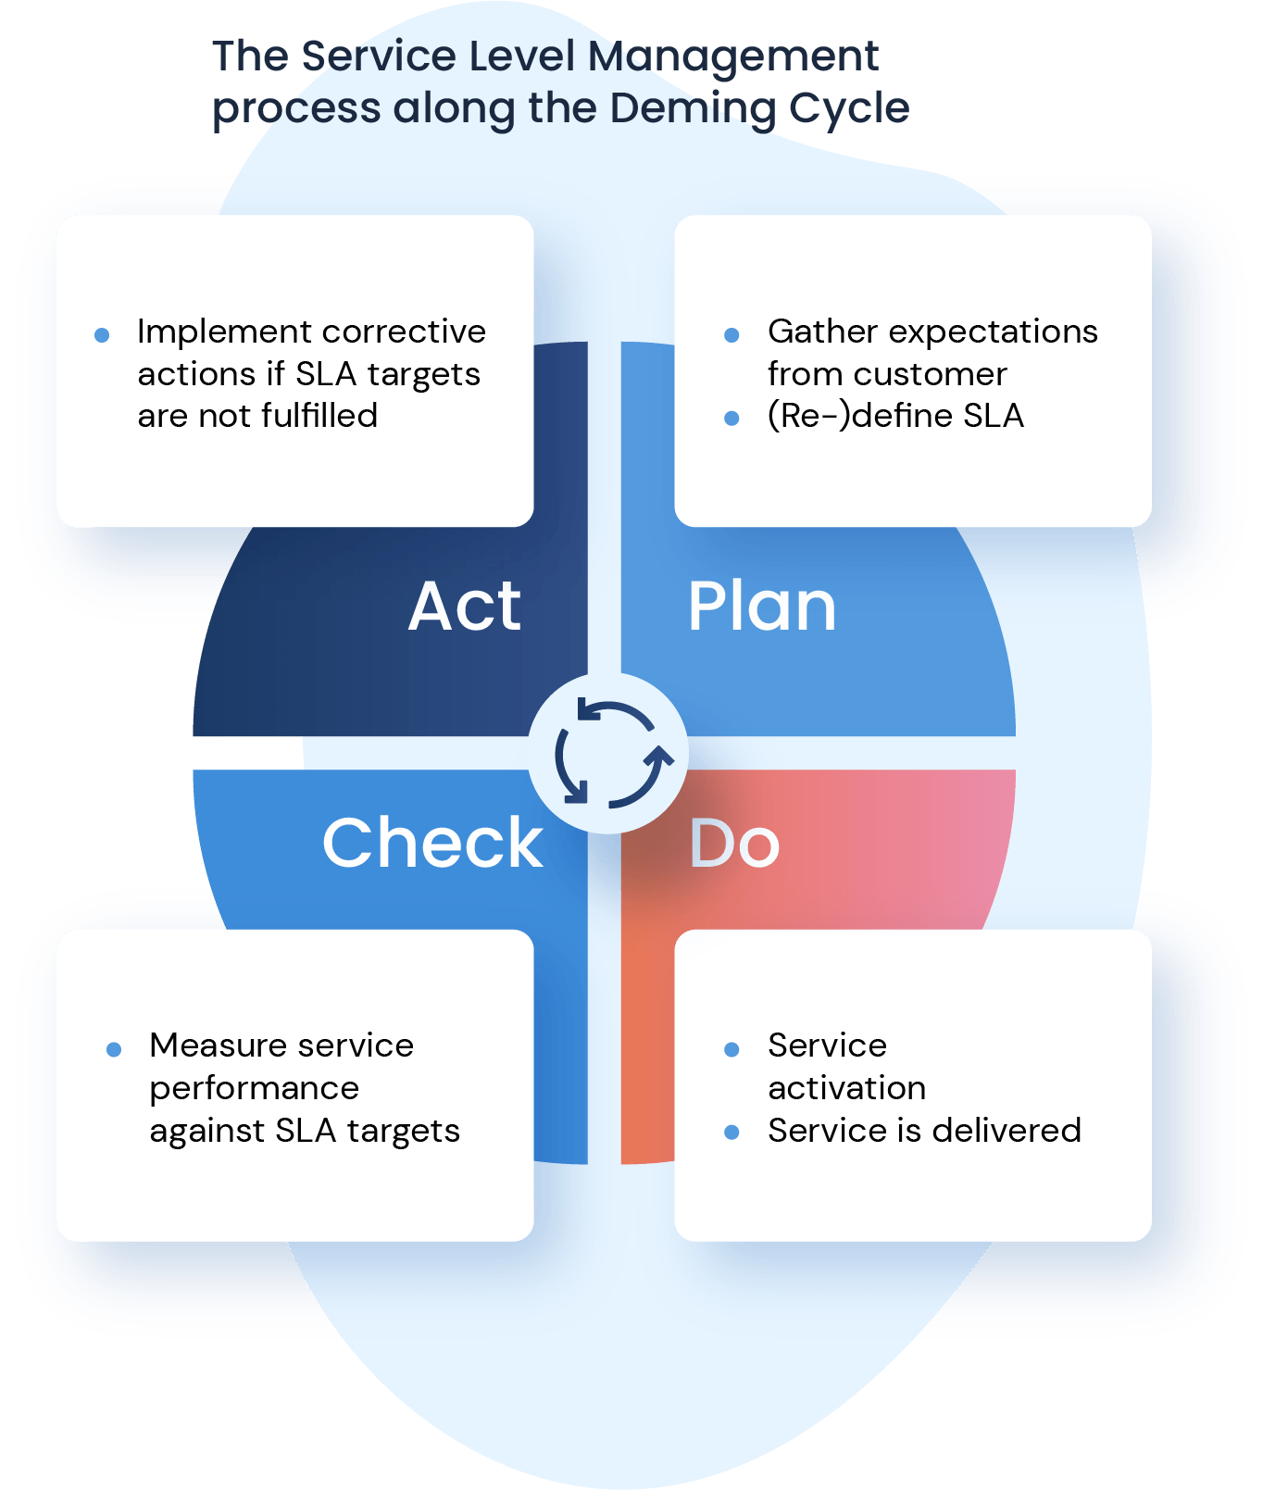  
https://www.google.com/url?sa=i&url=https%3A%2F%2Finvgate.com%2Fguides%2Fservice-level-management%2F&psig=AOvVaw0IgjFUzZ2AwSnCZRPcDvf5&ust=1716884923294000&source=images&cd=vfe&opi=89978449&ved=0CBQQjhxqFwoTCLCuovG0rYYDFQAAAAAdAAAAABAE

1. The process to implement SLAs comprises of the following activities in sequence:
   1. Draft SLAs, catalogue services, review underpinning contracts and OLAs, draft SLRs, negotiate, agree SLAs
   2. Draft SLAs, review underpinning contracts and OLAs, negotiate, catalogue services,
   3. Review underpinning contracts and OLAs, draft SLAs, catalogue services, negotiate, agree SLAs
   4. Catalogue services, establish SLRs, review underpinning contracts and OLAs, negotiate service levels, agree SLAs  
      This sequence aligns with the typical process of implementing Service Level Agreements (SLAs), where reviewing contracts and Operational Level Agreements (OLAs) precedes drafting SLAs, cataloging services, negotiating terms, and finally reaching agreement on the SLAs.  
       Reason  
      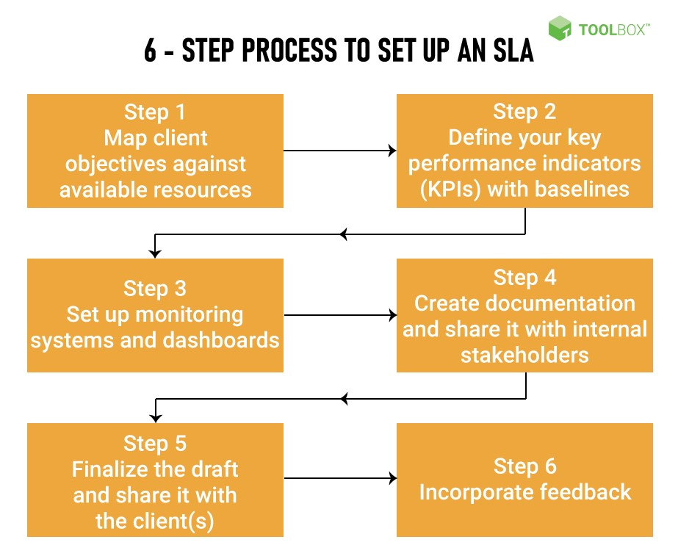  
      https://www.google.com/url?sa=i&url=https%3A%2F%2Fwww.spiceworks.com%2Ftech%2Fcloud%2Farticles%2Fwhat-is-a-service-level-agreement%2F&psig=AOvVaw3kRZYSivHGm27oh-Tt8VBn&ust=1716884977909000&source=images&cd=vfe&opi=89978449&ved=0CBQQjhxqFwoTCICwrIu1rYYDFQAAAAAdAAAAABAE
2. Which of the following is an example of a service level agreement (SLA) between information systems support unit and a research unit in the laboratories of a large company?
   1. The maximum response time to get the system operational should it fail.
   2. The minimum ‘up-time’.
   3. The types of information that will be provided as standard.
   4. All of the above. Reason  
      Reason: All the options provided are examples of elements that could be included in a Service Level Agreement (SLA) between an information systems support unit and a research unit in a company's laboratories. SLAs commonly specify response times, system uptime guarantees, and the types of information or support provided as standard.  
      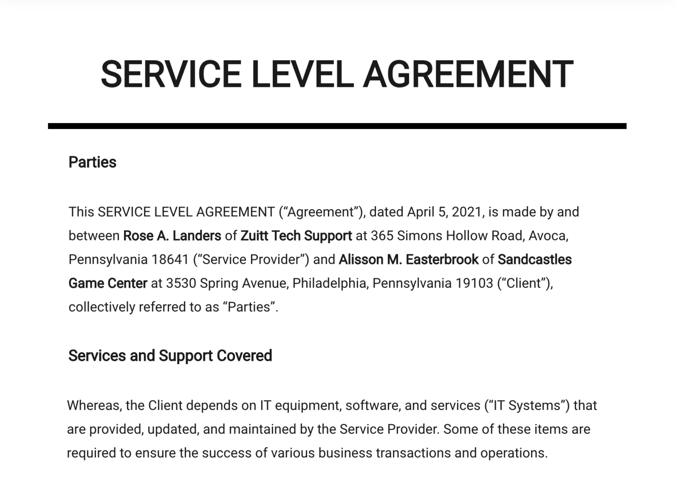  
      https://www.google.com/url?sa=i&url=https%3A%2F%2Fwww.zendesk.com%2Fblog%2Fkeeping-word-support-sla%2F&psig=AOvVaw0R0gncQixpnQEtQcV3iJs_&ust=1716885046890000&source=images&cd=vfe&opi=89978449&ved=0CBQQjhxqFwoTCKiPlay1rYYDFQAAAAAdAAAAABAE
3. Some organisations bring a degree of formality to the internal customer concept by encouraging (or requiring) different parts of the operation to agree on:
   1. Internal service agreements
   2. Service level agreements Reason
   3. Formal provision agreements
   4. Delivery agreements

Reason: Internal service agreements formalize the relationships and expectations between different parts of an organization, ensuring that internal services are provided efficiently and effectively.  
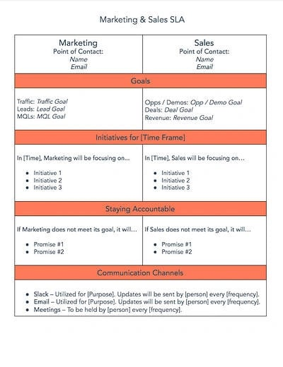  
https://www.google.com/url?sa=i&url=https%3A%2F%2Fblog.hubspot.com%2Fblog%2Ftabid%2F6307%2Fbid%2F34212%2Fhow-to-create-a-service-level-agreement-sla-for-better-sales-marketing-alignment.aspx&psig=AOvVaw0fSgCSM887YBQG_tyT1ZSf&ust=1716885114265000&source=images&cd=vfe&opi=89978449&ved=0CBQQjhxqFwoTCMjqnsy1rYYDFQAAAAAdAAAAABAE

## Index

B

bookstore 1

C

categories 6

closed-ended 7

D

data collection 9

L

Linux server 2

N

network 1

O

open-ended 7

S

Service Level 9

service level agreement 10

service quality 10

soft skills 5

support 3

T

technology 2

telecommunications 3